**Task 1;**

Directory doesn’t exists.

Created using the below command.



Task 2:

Go inside it using cd

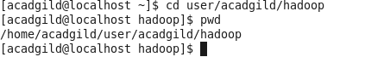

**Task 3:**

Create file using Nano



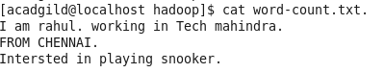

Task 4:

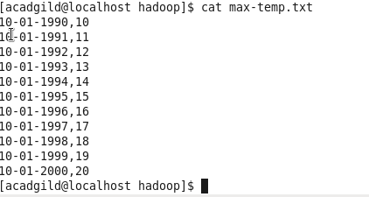

Task 5:

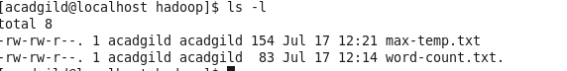

Change permission

